**11 Investigation 2 Methods: Out 14 June In class: 21 June**

**For the in class, you are allowed to bring this take home in with you plus any other notes. You will need your classpad for the in class as well.**

**Aim:** Explore the gradient of a chord or secant and generalise. Visually see the gradient of the tangent as the limiting value as the two points get closer together.

1. Explore the gradient of secant. Go to menu and open **InteractiveDiffCalc**



|  |  |
| --- | --- |
| **Define function**   * Open InteractiveDiffCalc * Tap Function tab * Enter *y*  *x* 2  *x*  3 |  |
| **Gather data on the secant** (line DE)   * Tap Tangent tab * Controls * Left right arrows * Press to fix value of *xD* or *xE* * Press to draw/hide tangent * Press to switch the fixed point |  |

 Complete the table of values

|  |  |  |  |  |  |
| --- | --- | --- | --- | --- | --- |
| D | E | Rise DE | Run DE | Gradient DE | Equation DE |
| 1 ,3  | 2 ,  1 | 2 | 1 | 2 | *y*  2*x*  5 |
| 1.5 ,  | 2 ,  1 |  |  |  |  |
| 2.5 ,  | 2 ,  1 |  |  |  |  |
| 1.9 ,  | 2 ,  1 |  |  |  |  |
| 1.99 ,  | 2 ,  1 |  |  |  |  |

 As D moves closer to point E, what happens to the:

* 1. two lines
  2. the gradient of the secant and the gradient of the tangent?

For the points *x*  *h*, *f* (*x*  *h*)

and

*x*, *f* (*x* )

write an expression for the

gradient of the secant and then simplify. (Hint: use M)

1. Explore the gradient of the tangent to a curve

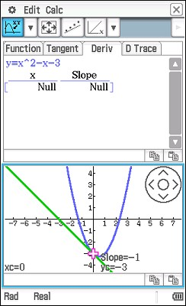

Explore the tangent using Deriv tab

•

•

•

Tap the

tab

Press the arrow keys to move the cursor

Press E or the centre of the on-screen wheel to plot a point

Or press a number key to type an *x*-value

Deriv

 What does the *y*-value of the plotted points represent?

 Complete the table.

|  |  |
| --- | --- |
| x | Gradient of tangent |
| 0 |  |
| 1 |  |
| 2 |  |
| 3.3 |  |
| –1.2 |  |

 Predict a function that describes the relationship between the gradient and *x*-value.

 Check your prediction.

Tap to enter your prediction for the gradient function. ClassPad will then plot your prediction. (Note: you must have plotted the gradient in at least 4 positions)

1. Explore the D Trace tab

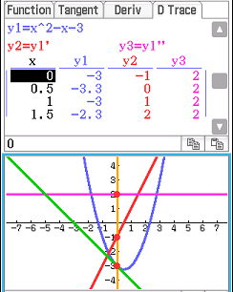

* Tap
* Move the left and right arrow keys.

•

Tap display.

to turn on/off different parts of the

D Trace

Refer to the graph in the screenshot above. What does the graph of  y2 (the redline) represent?

 y3 (the pink line) represent?

1. For each of the following functions:

* sketch the graph, the tangent at the specified point and the gradient function on the grid; and
* state the equation of the gradient function, *y* ' . that is ()



*y*  *x*4 with tangent at

*x*  2

*y*  *x*4  10 with tangent at *x*  2

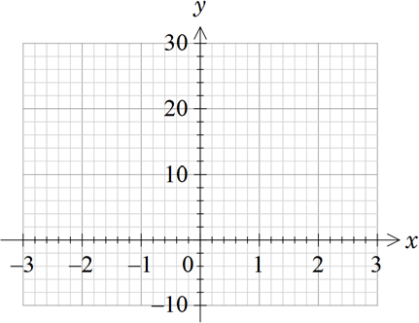 

Prediction for *y’*: Prediction for *y’*:

*y*  2*x*

with tangent at *x =* 3

*y*  sin *x*

with tangent at

*x*  **

3

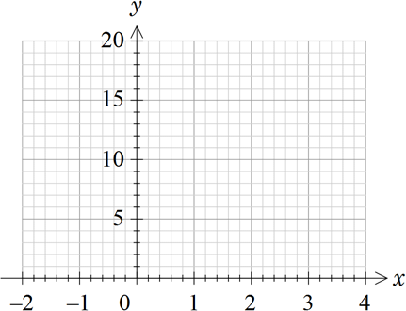 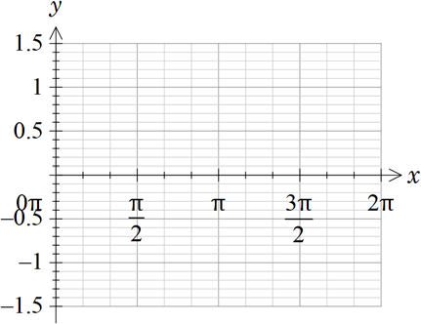

Prediction for *y’*:

Prediction for *y’*:

1. The screenshot reproduces the steps in this activity done algebraically.

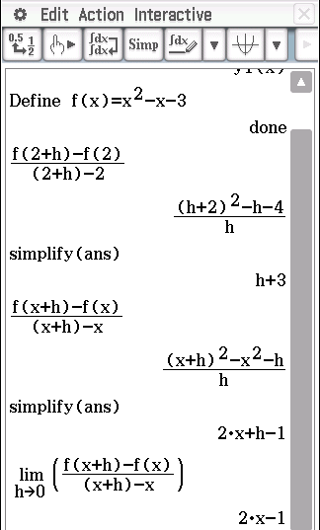

Reproduce the screenshot as shown.

1. Define the function
2. Write and expression for the gradient of a secant between 2, *f* (2) and 2  *h*, *f* (2  *h*)

and simplify

As *h*  0 the secant approaches the tangent at *x*  2 . (In this case the gradient of the tangent will be 3)

1. Write and expression for the gradient of a secant between *x*, *f* (*x* ) and *x*  *h*, *f* (*x*  *h*)

and simplify

As *h*  0 the secant approaches the tangent at any point

1. Calculate derivative function using first principles formula

Edit the function definition to complete the table.

|  |  |  |  |
| --- | --- | --- | --- |
| Function | Gradient of tangent at *x*  2 | Gradient of secant between  *x*, *f* (*x* ) and *x*  *h*, *f* (*x*  *h*) | Gradient function |
| *x*2  *x*  3 | 3 | 2*x*  *h*  1 | 2*x*  1 |
| *x* 3 |  |  |  |
| *x* 4 |  |  |  |
| 5*x* 3 |  |  |  |
| 1  *x* or *x* 2 |  |  |  |
| sin *x* |  |  |  |
| cos *x* |  |  |  |
| 2*x* |  |  |  |

1. EXTENSION

Predict the gradient functions for

 *y*  *xn*

 *y*  *axn*

 *y*  *xn*  *xm*

**Learning notes**

The strength in the InteractiveDiffcalc app is being able to follow the first principles approach visually. By dynamically moving the points closer together students can see the secant getting closer to the tangent.

It also supports the development of the idea of the gradient function and taking time to understand the plotting of the gradient at specific points is a neat way of encouraging students to develop this concept.



|  |  |
| --- | --- |
| Tangent tab   * Controls * Left right arrows * Press to fix value of *xD* or *xE* * Press to draw/hide tangent * Press to switch the fixed point |  |
| Deriv tab   * Press the arrow keys to move the cursor * Press E or the centre of the on-screen wheel to plot a point   Or press a number key to type an *x*-value   * Press  to calculate a regression   see pull down menu for types of regression   * Press to enter prediction for the gradient function |  |
| D Trace tab   * Move the left and right arrow keys. * Tap to cycle through different displays |  |